# **Part 1: hello.c**

## Script:

#include <linux/module.h>

#include <linux/kernel.h>

int init_module(void)

{

printk (KERN_INFO "Hello world\n");

return 0;

}

void cleanup_module(void)

{

printk (KERN_INFO "<1>Goodbye cruel world\n");

}

## Screenshot of IP address and Output:

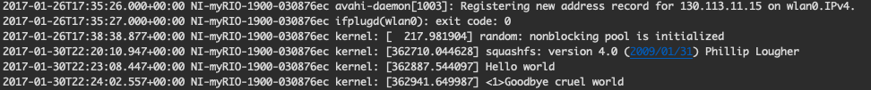

## Screenshot of loaded module:

## Screenshot of unloaded module:

# **Part 2: hello2.c**

## Script:

#include <linux/module.h>

#include <linux/kernel.h>

#include <linux/init.h>

static int foo __initdata = 2;

static int __init init_custom_module(void)

{

printk (KERN_INFO "Hello dummy world %d\n", foo);

return 0;

}

static void __exit cleanup_custom_module(void)

{

printk (KERN_INFO "<1>Hello cruel world2\n");

}

module_init(init_custom_module);

module_exit(cleanup_custom_module);

## Screenshot of IP address and Output:

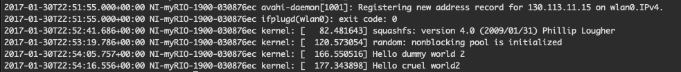

## Screenshot of loaded module:

# **Part 3: hello3.c**

## Script:

#include <linux/module.h>

#include <linux/kernel.h>

#include <linux/init.h>

#define DRIVER_AUTHOR "Adam+Harneet"

#define DRIVER_DESC "4AA4 Lab2 Part3"

static int foo __initdata = 2;

static int __init init_custom_module(void)

{

printk (KERN_INFO "Hello dummy world %d\n", foo);

return 0;

}

static void __exit cleanup_custom_module(void)

{

printk (KERN_INFO "<1>Hello cruel world2\n");

}

module_init(init_custom_module);

module_exit(cleanup_custom_module);

MODULE_LICENSE("GPL");

MODULE_AUTHOR(DRIVER_AUTHOR);

MODULE_DESCRIPTION(DRIVER_DESC);

## Screenshot of IP address and Output:

## Screenshot of loaded module:

# **Part 4: hello4.c**

## Script:

#include <linux/module.h>

#include <linux/kernel.h>

#include <linux/init.h>

#define DRIVER_AUTHOR "Adam+Harneet"

#define DRIVER_DESC "4AA4 Lab2 Part3"

static char *my_name = "harneet";

static int __init init_custom_module(void)

{

printk (KERN_INFO "Hello dummy world %s\n", my_name);

return 0;

}

static void __exit cleanup_custom_module(void)

{

printk (KERN_INFO "Goodbye, %s\n", my_name);

}

module_init(init_custom_module);

module_exit(cleanup_custom_module);

module_param(my_name, charp, 0000);

MODULE_PARM_DESC(my_name, "Your name string");

MODULE_LICENSE("GPL");

MODULE_AUTHOR(DRIVER_AUTHOR);

MODULE_DESCRIPTION(DRIVER_DESC);

## Screenshot of IP address and Output:

## Screenshot of loaded module:

